# CHAPTER I INTRODUCTION

## Overview of Court Case Management

The court case management software is used to add case and hire advocate for that case online. This software is request advocate to handle our case once the advocate accepted our case this app will be alert petitioner/respondent about the advocate acceptance. And this app is also having a facility to transfer money online to advocate and generate invoice for each transaction with GST. The court case management software will have a cloud storage to store case evidence and important case documents those document is being encrypted using AES encryption algorithm. Here a chat app is available that will help advocate and petitioner to communicate more case details. This app is also having consultation part that will help petitioner/respondent to consult about case details before adding case and consult general law rules and regulations

## History

In 1861, the Indian High Courts Act 1861 was enacted to create high courts for various provinces and abolished supreme courts at Calcutta, Madras and Bombay and also the sadar adalats in presidency towns which had acted as the highest courts in their respective regions. These new high courts had the distinction of being the highest courts for all cases till the creation of the Federal Court of India under the Government of India Act 1935. The Federal Court had jurisdiction to solve disputes between provinces and federal states and hear appeals against judgements of the high courts. The first CJI of India was H. J. Kania. The Supreme Court of India came into being on 28 January 1950. It replaced both the Federal Court of India and the Judicial Committee of the Privy Council which were then at the apex of the Indian court system. The first proceedings and inauguration, however, took place on 28 January 1950 at 9:45 am, when the judges took their seats. Which is thus regarded as the official date of establishment. The Supreme Court initially had its seat at the Chamber of Princes in the parliament building where the previous Federal Court of India sat from 1937 to 1950. The first Chief Justice of India was H. J. Kania. In 1958, the Supreme Court moved to its present premises. Originally, the Constitution of India envisaged a supreme court with a chief justice and seven judges; leaving it to the parliament to increase this number. In formative years, the Supreme Court met from 10 to 12 in the morning and then 2 to 4 in the afternoon for 28 days in a month. Store and orders flowers and then goes to the ticket shop and gets the tickets for the show, and everything is communicated to both parties."

## Architecture

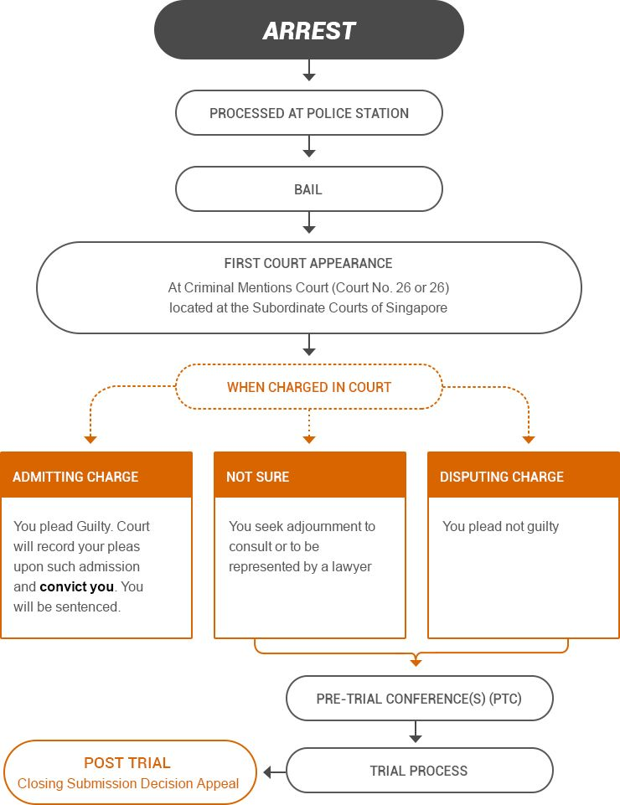

*Fig. 1.1 Court Procedure Architecture*

## Definition

The CCM (Court case management) System is used add case and hire advocate for that case in online. This app will store case documents and case evidence

## 1.4Tools.

## Xampp

XAMPP stands for Cross-Platform (X), Apache (A), MySQL (M), PHP (P) and Perl (P). It is a simple, lightweight Apache distribution that makes it extremely easy for developers to create a local web server for testing purposes. Everything you need to set up a web server – server application (Apache), database (MySQL), and scripting language (PHP) – is included in a simple extractable file. XAMPP is also cross-platform, which means it works equally well on Linux, Mac and Windows. Since most actual web server deployments use the same components as XAMPP, it makes transitioning from a local test server to a live server is extremely easy as well. Web development using XAMPP is especially beginner friendly.

## Apache

Apache is the actual web server application that processes and delivers web content to a computer.

Apache is the most popular web server online

## MySQL

A tool(Database) used for store case details

## 1.4.4 Visual Studio Code

Visual studio code is used to edit the program and save that program

## 1.4.5 Phpmyadmin

Phpmyadmin is a tool that will help MySQL database to store values

# CHAPTER II FEASIBILITY STUDY

## Proposed Work

The proposed software product is The court case management software is used to add case and hire advocate for that case online. This software is request advocate to handle our case once the advocate accepted our case this app will be alert petitioner/respondent about the advocate acceptance. And this app is also having a facility to transfer money online to advocate and generate invoice for each transaction with GST. The court case management software will have a cloud storage to store case evidence and important case documents those document is being encrypted using AES encryption algorithm. Here a chat app is available that will help advocate and petitioner to communicate more case details. This app is also having consultation part that will help petitioner/respondent to consult about case details before adding case and consult general law rules and regulations

.

## Advantage

* + - * File remains secure both on cloud and during transmission.
      * The app is transfer money online
      * This app will generate Invoice
      * Easy to Add Case
      * Easy to Hire Advocate
      * Consult Advocate Online
      * Get Case Status

## Hardware Requirements

Processor : Core i3/i5/i7 RAM : 2-4 GB

HDD : 500 GB

## Software Requirements:

Platform : Windows 7/8/10

Front End : Xampp, PHP, 000 Webhost Cloud server Back End : MySQL

Software : CryptoFS, MOLE decryptor

## Software Tools

* + 1. **PHP**

PHP is a popular general-purpose scripting language that is especially suited to web development. It was originally created by Rasmus Lerdorf in 1994; the PHP reference implementation is now produced by The PHP Group. PHP originally stood for Personal Home Page, but it now stands for the recursive initialism PHP: Hypertext Preprocessor. PHP code is usually processed on a web server by a PHP interpreter implemented as a module, a daemon or as a Common Gateway Interface (CGI) executable. On a web server, the result of the interpreted and executed PHP code — which may be any type of data, such as generated HTML or binary image data — would form the whole or part of a HTTP response. Various web template systems, web content management systems, and web frameworks exist which can be employed to orchestrate or facilitate the generation of that response. Additionally, PHP can be used for many programming tasks outside of the web context, such as standalone graphical applications and robotic drone control. Arbitrary PHP code can also be interpreted and executed via command line interface (CLI). The standard PHP interpreter, powered by the Zend Engine, is free software released under the PHP License. PHP has been widely ported and can be deployed on most web servers on almost every operating system and platform, free of charge. The PHP language evolved without a written formal specification or standard until 2014, with the original implementation acting as the de facto standard which other implementations aimed to follow. Since 2014, work has gone on to create a formal PHP specification.

## Visual Studio Code

Visual Studio Code is a source-code editor developed by Microsoft for Windows, Linux and macOS. It includes support for debugging, embedded Git control and GitHub, syntax highlighting, intelligent code completion, snippets, and code refactoring. It is highly customizable, allowing users to change the theme, keyboard shortcuts, preferences, and install extensions that add additional functionality. The source code is free and open source and released under the permissive MIT License.

The compiled binaries are freeware and free for private or commercial use.

# CHAPTER III SYSTEM DESIGN

## 3.1 System Architecture

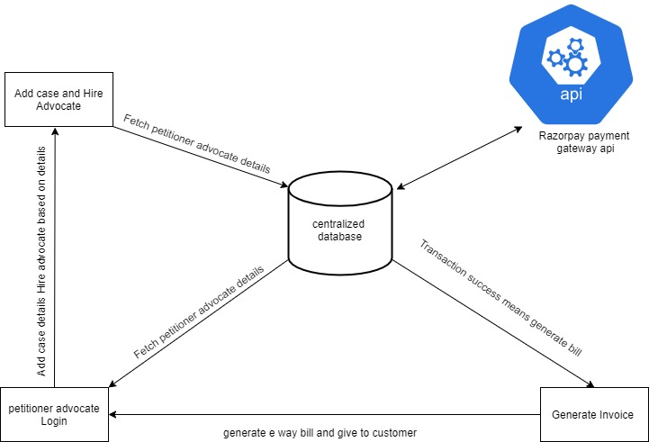

*Fig. 3.1 System Architecture*

The Petitioner/Advocate must register in this application after which they will get OTP confirmation. Once login successfully petitioner can add the case details and hire Advocate.The Advocate will submit case details to the court (offline). Then Advocate has to enter CNR number ,court order and next hearing date after receiving those details from court. The Advocate will request to the petitioner regarding payment details. Then the system will show the transaction alert in petitioner dashboard . Once petitioner click pay now button the page is redirected to transaction process. If the transaction is success then the application shows invoice to petitioner and also have facility to print invoice.

## 3.1.1 Use Case

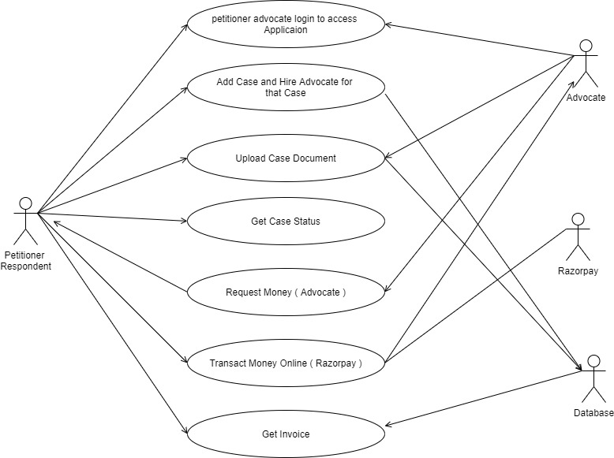

*Fig. 3.2 Use case diagram for court case management software*

## 3.2Types of Modules

* + - Login Access and Authentication
    - Add Case and Hire Advocate.
    - Online Transaction with Invoice
    - Etc.

## 3.2.1 Login Access and Authentication

In this module user want to get the services of court case management , so the user initially registers with the cloud service provider. admin provides an access code OTP only for the authorized user. User request for the access from the admin to use the data that is present in the cloud. login access is provided with the access code and authenticity is provided by issuing user name and password.

## Class diagram :

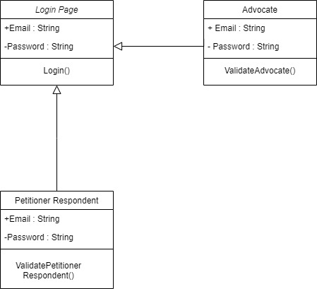

*Fig. 3.3 Class diagram for Login Access and Authentication*

## Description

In this module the petitioner / respondent is have register first the name, email, mobile number, password is required field to register user once the registration process done the petitioner / respondent will get an OTP to confirm email id the Email id and Password will be used to login to dashboard the email id is string and password is hidden string (Not visible)

## Collaboration diagram

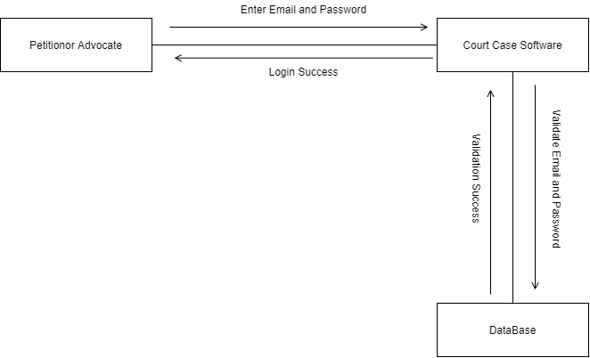

*Fig 3.4 collaboration diagram for Login Access and Authentication*

## Description

In this module, user initially starts the flow with registering in the CCM to access the further data. The software provide authentication code that is OTP. user gets authenticated by an email id and password. This implies that the user is authorized and can retrieve the required case details from the Storage. Local server allocates space from the cloud to the user.

## Sequence diagram

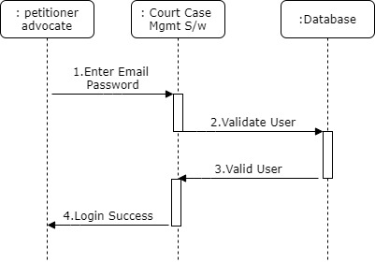

*Fig 3.5 Sequence diagram for Login Access and Authentication*

## Description

In this module, the petitioner / respondent and advocate initially starts the flow with registering in the CCM to access the add case and hire advocate for that case . here the user will enter email id and password to login if the user enters invalid email id and password the software will show alert like your entering invalid user email id and password

If the user enters valid email id and password it redirects to a petitioner / respondent dashboard and the it will show the count of case, advocate of the petitioner /respondent

## Add Case and Hire Advocate

In this module once the petitioner / respondent is logged in the dashboard will show here the petitioner / respondent will add case and hire advocate for that case the case adding form will contain respondent name and email, mobile number, address, those field are not required field. Case description is required field that text area to fill entire case details here

Once the case adding process done it automatically recommend an advocate based on the case details the content based recommendation system will be implemented here to hire advocate for that case it will recommend advocate by practice area and rating, experience, and winning percentage of previous cases of that advocate is the process of hiring

## Class diagram

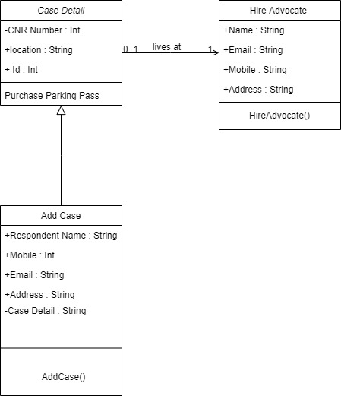

*Fig 3.6 Class diagram for add case and hire advocate for that case*

## Description

In this module the petitioner / respondent will be have a add case and hire advocate based on case details here the case details can be contain CNR Number location of court and id of that case the add case will be contain the respondent name, mobile, email, address, case details, based on case details the process will redirect to hire advocate for that case

## Collaboration diagram

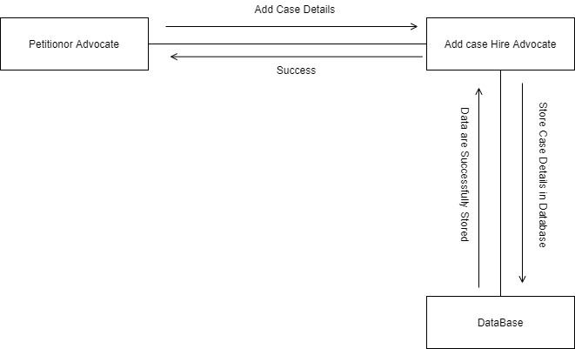

*Fig 3.7 Collaboration diagram for add case and hire advocate*

## Description

In this module the petitioner / respondent will add case hire advocate based on case details those data are stored in database and the process will alert an petitioner / respondent to the data are successfully stored in database

## Sequence diagram

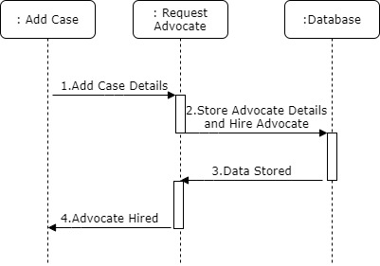

*Fig 3.8 Sequence diagram for Add case and hire advocate*

## Description

In this module the petitioner / respondent will add case hire advocate based on case details those data are stored in database and the process will alert an petitioner / respondent to the data are successfully stored in database

* + 1. **Online Transaction with Invoice**

In this module once the advocate will work for petitioner so he/she has send request money for their work. The online transaction will be done with help razorpay payment gateway tool the api is called to access online transaction. The transaction will contain all possible type like (credit/debit card, Net banking, upi transaction, wallet transaction, etc…) The petitioner has to select the type of transaction once the type is selected, the transaction processing if the transaction success means it will redirect to success page the petitioner / respondent has a facility to print invoice. if the transaction fail it will redirect to new transaction page.

## Class diagram

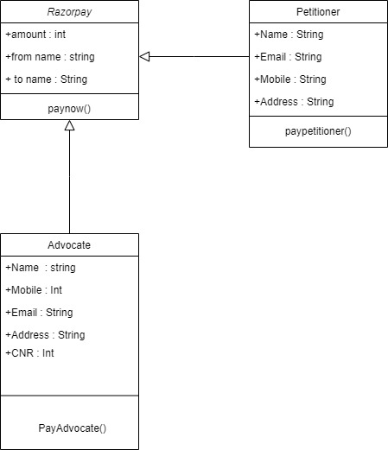

*Fig 3.9 Class diagram for Online Transaction*

## Description

In this module once the advocate will request a petitioner to send their money for their work. The online transaction will be done with help third party payment gateway tool the API is called to access online transaction. The transaction will contain all possible type. The petitioner has to select the type of transaction once the type is selected, the transaction processing if the transaction success means it will redirect to success page the petitioner / respondent has a facility to print invoice. if the transaction fail it will redirect to new transaction page.

## Collaboration diagram

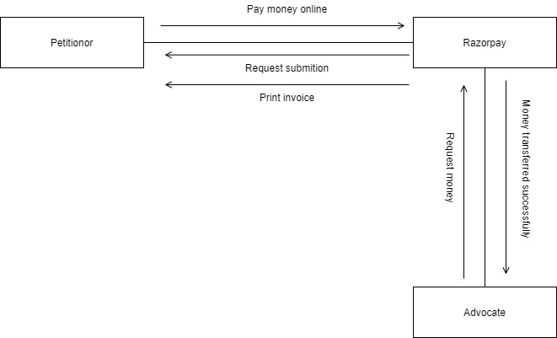

*Fig 3.10 Collaboration diagram for Online Transaction*

## Description

In this module the petitioner / respondent will add case hire advocate based on case details those data are stored in database and the process will transfer money to advocate with help of Razorpay payment gateway tool

## Sequence diagram

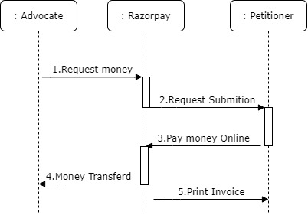

*Fig 3.11 Sequence diagram for Online transaction and print invoice*

## Description

In this module the petitioner / respondent

# CHAPTER IV

# SYSTEM IMPLEMENTATION

## Configuration

<?php

$con=new mysqli("localhost","root","","court"); if($con->connect_error)

{

echo $con->connect_error; die("Sorry Database Error");

}

else{

//echo"database connected";

}

?>

## Index.php

<!DOCTYPE html>

<?php

include("functions.php");

?>

<html lang="en">

<head>

<meta charset="UTF-8">

<meta name="viewport" content="width=device-width, initial-scale=1.0">

<meta http-equiv="X-UA-Compatible" content="ie=edge">

<title>Court Case Management System</title>

<link rel="stylesheet" type="text/css" href="css/style.css">

<link rel="icon" type="image/icon" href="images/icon.png">

<link rel=stylesheet href=css/aos.css />

<script src=css/aos.js></script>

<link rel="stylesheet" href="https://maxcdn.bootstrapcdn.com/bootstrap/4.0.0/css/bootstrap.min.css">

<script src="https://ajax.googleapis.com/ajax/libs/jquery/3.3.1/jquery.min.js"></script>

<script src="https://cdnjs.cloudflare.com/ajax/libs/popper.js/1.12.9/umd/popper.min.js"></script>

<script src="https://maxcdn.bootstrapcdn.com/bootstrap/4.0.0/js/bootstrap.min.js"></script>

<script src="https://use.fontawesome.com/releases/v5.0.8/js/all.js"></script>

<link rel="icon" type="image/icon" href="image/icon.png">

<link rel="stylesheet" href="https://cdnjs.cloudflare.com/ajax/libs/font-awesome/4.7.0/css/font-awesome.min.css">

<link rel="stylesheet" href="https://cdnjs.cloudflare.com/ajax/libs/animate.css/3.7.2/animate.min.css">

</head>

<body>

<div id="indextopback">

<div id="head" class="container-fluid">

<div id="phone"><p class="text-white"><i class="fa fa-mobile text-white"> </i> +91 99410-99140 &nbsp;&nbsp;&nbsp;| &nbsp;&nbsp;&nbsp; <i class="fa fa-phone-square text-white"> </i> &nbsp; +91 866 733 6507 | &nbsp;&nbsp;&nbsp; <i class="fa fa-envelope text-white"> </i> &nbsp; contact@ccm.com </p></div>

</div>

<nav id="header" class="navbar navbar-expand-md navbar-light sticty-top">

<a href="#" class="navbar-brand"><img src="images/logo.png" alt="logo"></a>

<button class="navbar-toggler" type="button" data-toggle="collapse" data-target="#navbarRes"><span class="navbar-toggler-icon"></span></button>

<div id="navbarRes" class="collapse navbar-collapse">

<ul class="navbar-nav ml-auto">

<center><li class="nav-item active"> <a href="index.php" class="nav-link">Home</a> </li></center>

<center><li class="nav-item"> <a href="hire_lawer.php" class="nav-link">Hire an Advocate</a> </li></center>

<center><li class="nav-item"> <a href="new_lawyer.php" class="nav-link">Join us Advocate</a> </li></center>

<center><li class="nav-item "> <a href="career.php" class="nav-link">Careers</a> </li></center>

<center>

<li class="nav-item dropdown dropdown-menu-right">

<div class="btn-group">

<button type="button" class=" animated bounce btn btn-outline-light dropdown-toggle " data-toggle="dropdown" aria-haspopup="true" aria-expanded="false">

Login

</button>

<div class="bg-dark dropdown-menu dropdown-menu-right">

<button class="dropdown-item" type="button"><a href="user_login.php" class="nav-link">Petitioner login</a></button>

<button class="dropdown-item" type="button"><a href="lawyer_login.php" class="nav-link">Advocate login</a></button>

</div>

</div>

</li>

</center>

</ul>

</div>

</nav>

<div id="slides" class="carousel slide" data-ride="carousel">

<div class="carousel-caption" id="carousel-caption">

<h1 id="slideh1" class="display-4">The greatest and strongest firm<br/><span id="orange"> you can trust</span></h1>

<button class="btn btn-outline-white btn-lg"><a href="#conbox">for more</a></button>

<button class="btn btn-info btn-lg">contact</button>

</div>

</div>

</div>

<center>

<div id="conbox" class="row w-100 text-white" >

<div class="col-md p-5" id='dark-black'>

<h4>Solve your queries</h4><br>

<p class="text-white">

Ask free legal questions related

to your business and make

smart legal decisions.

</p>

</div>

<div class="col-md p-5 bg-dark">

<h4>Lawyers on-Call</h4>

<br>

Discuss your legal issue with

an expert lawyer on-call.

Anytime, Anywhere.

</div>

<div class="col-md p-5" id='dark-black1'>

<h4>Book appointment</h4>

<br>

<p>Book appointment with your

preferred Lawyer. Don't worry,

your first consultation is free.</p>

</div>

</div>

</center>

<center>

<div class="row w-100 text-white" >

<div class="col-md p-5 bg-dark" >

<h4>Will Drafting & Agreement</h4><br>

<p class="text-white">

Make your legal Will online in simple and easy steps. Get your will drafted and property registered from the best property lawyer.

</p>

</div>

<div class="col-md p-5" id='dark-black1'>

<h4>Cheque & Money Recovery</h4>

<br>

Consult a top lawyer for Cheque Bounce & Money Recovery India to solve all your Cheque Bounce issues at an affordable cost.

</div>

<div class="col-md p-5 bg-dark">

<h4>Court Marriage & Registration</h4>

<br>

<p>Apply for a marriage certificate online. Marriage registration process explained by best family lawyer online.

</p>

</div>

</div>

</center>

<div class="bg-light p-5">

<center>

<h2 class="text-dark">Get a free Ouotes</h2>

<p class="text-dark">Get free quotes online from top lawyers across India dealing in the specific practice area.</p>

<p class="text-dark">to know more about us please Enter your email id</p>

<form action="" class='form-group' method="post">

<input type="email" name="subscribeemail" placeholder="Enter your e-mail id ......" class='form-control container w-75' id="">

<input type="submit" value="Subscribe" name='subscribesubmit' class='btn btn-success mt-2 form-control w-50'>

</form>

</center>

</div>

<div class="bg-light p-5 border border-left-0 border-right-0 border-bottom-0 ">

<div class="row">

<div class="col-md bg-dark p-5">

<center><h3 class="text-white">Why we ?</h3></center> <br>

<p class="text-white text-justify">

We provide a platform where you can search Best Lawyers in India. Clients can raise query and get free legal advice from the Best Advocates in India. Apart from being useful for users to search lawyers and seeking legal advice, this website serves as an attractive marketing platform for advocates free of cost.Consult & Hire Best Lawyers in India and get Free Legal Advice Online India by Top Advocates in India at CCM.

A platform where clients can search and meet Top Advocates of their city and Best Lawyers in India and get free legal advice online.

© Connections Pvt. Ltd. ‐ All Rights Reserved

</p>

</div>

<div class="col-md bg-white border border-dark p-5">

<center><h3 class="text-dark">Who we are?</h3></center> <br>

<p class="text-dark text-justify">

We provide a platform where you can search Best Lawyers in India. Clients can raise query and get free legal advice from the Best Advocates in India. Apart from being useful for users to search lawyers and seeking legal advice, this website serves as an attractive marketing platform for advocates free of cost.Consult & Hire Best Lawyers in India and get Free Legal Advice Online India by Top Advocates in India at CCM.

A platform where clients can search and meet Top Advocates of their city and Best Lawyers in India and get free legal advice online.

© Connections Pvt. Ltd. ‐ All Rights Reserved

</p>

</div>

</div>

</div>

<script src="https://ajax.googleapis.com/ajax/libs/jquery/3.3.1/jquery.min.js"></script>

<div class="container bg-white p-5 " data-aos="fade-in">

<div class="item-animate">

<div class="row" id="countId">

<div class="col-md">

<h2 class="text-center">Our Customers</h2>

<h2 class="text-center code">0</h2>

</div>

<div class="col-md">

<h2 class="text-center ">Our Cases</h2>

<h2 class="text-center code">0</h2>

</div>

<div class="col-md">

<h2 class="text-center">Our Lawyers</h2>

<h2 class="text-center code">0</h2>

</div>

</div>

</div>

</div>

<script>

jQuery(function($) {

$(window).on('scroll', function() {

$({ countNum: $('.code').html() }).animate({ countNum: 99999 }, {

duration: 2000,

easing: 'linear',

step: function () {

$('.code').html(Math.floor(this.countNum) + "+");

},

complete: function () {

$('.code').html(this.countNum + "+");

//alert('finished');

}

});

});

});

</script>

<div id=footer class="mt-5 p-4 bg-dark text-white col">

<div class="row container">

<div id class="col-xl-4 col-lg-6 col-md-8 col-sm-10 p-3">

<h6 class=text-white>News Letter</h6>

<form action=subscribe_email.php method=post class=form-group>

<input type=email name=emailnews required class="form-control mt-2" placeholder="Enter your email id ........" id>

<input type=submit name=submitnews value=submit class="btn btn-success mt-3"> <br> <br>

</form>

</div>

<div id class="col-xl-3 col-lg-6 col-md-8 col-sm-10 p-3">

<h6 class=text-white>Follow us </h6>

<div id=social>

<a target=_block class=text-white href=#> <i class="fab fa-facebook"></i></a>

<a target=_block class=text-white href=#> <i class="fab fa-twitter-square"></i></a>

<a target=_block class=text-white href=#> <i class="fab fa-whatsapp-square"></i></a>

<a target=_block class=text-white href=#> <i class="fab fa-instagram"></i></a><span></div>

</div>

<div id class="col-xl-2 col-lg-6 col-md-8 col-sm-10 p-3">

<h6 class=text-white> Get to Know Us </h6>

<div class=ml-2>

<a target=_block href=about.php class=text-white>About Us </a> <br>

<a target=_block href=career.php class=text-white>Careers</a> <br>

<a target=_block href=contact.php class=text-white>Contact us</a> <br>

<a target=_block href=tems_conditions.php class=text-white>Terms</a> <br>

<a target=_block href=faq.php class=text-white>FAQ</a> <br>

</div>

</div>

<div id class="col-xl-3 col-lg-6 col-md-8 col-sm-10 p-3">

<h6 class=text-white>Registered Office Address: </h6>

<p class=text-white>

Court Case Management System,<br>

</b> 192, National Highway,

New Delhi, Andaman<br>

India<br>

Telephone: 1234567890<br/>

Whatsapp: 1234567890

</p>

</div>

</div>

<hr class=bg-white>

<div class=row>

<div id class="col-md p-3">

<p> Copyrights &copy; 2019-<?php echo date("Y") ?>, ccm.com, its affiliates</p>

</div>

<div id class="col-md p-3 text-center">

<p> Designed by Praveen Kumar Vel</p>

</div>

</div>

</div>

</body>

</html>

<div id=topbtn>

<a href=#header> <img src=images/top.png alt=topicon></a>

</div>

<script>AOS.init({duration:1100,});</script>

**Add_new_case.php**

<?php

include("functions.php");

session_start();

if(!isset($_SESSION["useremail"]))

{

echo"<script type='text/javascript'>window.location='index.php';</script>";

}

?>

<!DOCTYPE html>

<html lang="en">

<head>

<meta charset="UTF-8">

<meta name="viewport" content="width=device-width, initial-scale=1.0">

<meta http-equiv="X-UA-Compatible" content="ie=edge">

<link rel="stylesheet" type="text/css" href="css/style.css">

<link rel="icon" type="image/icon" href="images/icon.png">

<link rel=stylesheet href=css/aos.css />

<script src=css/aos.js></script>

<link rel="stylesheet" href="https://maxcdn.bootstrapcdn.com/bootstrap/4.0.0/css/bootstrap.min.css">

<script src="https://ajax.googleapis.com/ajax/libs/jquery/3.3.1/jquery.min.js"></script>

<script src="https://cdnjs.cloudflare.com/ajax/libs/popper.js/1.12.9/umd/popper.min.js"></script>

<script src="https://maxcdn.bootstrapcdn.com/bootstrap/4.0.0/js/bootstrap.min.js"></script>

<script src="https://use.fontawesome.com/releases/v5.0.8/js/all.js"></script>

<link rel="icon" type="image/icon" href="image/icon.png">

<link rel="stylesheet" href="https://cdnjs.cloudflare.com/ajax/libs/font-awesome/4.7.0/css/font-awesome.min.css">

<link rel="stylesheet" href="https://cdnjs.cloudflare.com/ajax/libs/animate.css/3.7.2/animate.min.css">

<script src="https://cdnjs.cloudflare.com/ajax/libs/sweetalert/2.1.2/sweetalert.min.js"></script>

<title>User dashboard</title>

</head>

<body>

<script>

function openNav() {

document.getElementById("sidebar").style.width = "200px";

}

function closeNav() {

document.getElementById("sidebar").style.width = "0";

}

</script>

<center>

<div id="dashboardfull" class="bg-white row">

<div id="sidebar" class="sidenav bg-dark">

<button href="javascript:void(0)" class="closebtn btn btn-light float-right" onclick="closeNav()">&times;</button>

<img src="images/logo.png" alt="">

<img src="images/one.png" style="padding:0px;margin:0px;" alt="">

<a href="consult_now.php"><i class="fa fa-gavel "> </i>&nbsp;&nbsp; Consult Now</a>

<a href="user_profile.php"><i class="fa fa-user"> </i> &nbsp;&nbsp;My Profile</a>

<a href="my_case.php"><i class="fa fa-users"> </i >&nbsp;&nbsp;My Cases</a>

<a href="my_documents.php"><i class="fas fa-book"> </i> &nbsp;&nbsp;My Documents</a>

<a href="my_transaction.php"><i class="fa fa-globe"> </i> &nbsp;&nbsp;Transactions</a>

<a href="faq.php"> <i class="fa fa-question"> </i>&nbsp;&nbsp; FAQ</a>

</div>

<div id="openbtn" class="text-dark">

<button class="btn btn-dark btn-md" onclick="openNav()">&#9776;</button>

Welcome : <?php echo $_SESSION["useremail"];?>

<button class="navbar-toggler bg-white" type="button" data-toggle="collapse" data-target="#navbarRes"><span class="pb-2 text-dark" style="font-size:20px;">&#9776;</span></button>

</div>

<div id="dashboard">

<div id="navbar" class="navbar navbar-expand-md navbar-light sticty-top">

<div id="navbarRes" class="collapse navbar-collapse">

<ul class="navbar-nav ml-auto">

<center><li class="nav-item active"> <a href="user_dashboard.php" class="nav-link">Home</a> </li></center>

<center><li class="nav-item active"> <a href="hire_lawer.php" class="nav-link">Hire Advocate Now</a> </li></center>

<center><li class="nav-item active"> <a href="add_new_case.php" class="nav-link">Add new Case</a> </li></center>

<center><li class="nav-item active"> <a href="chat_now.php" class="nav-link">Chat Now</a> </li></center>

<center><li class="nav-item active"> <a href="contact.php" class="nav-link">Contact</a> </li></center>

<center><li class="nav-item active"> <a href="logout.php" class="nav-link">Logout</a> </li></center>

</ul>

</div>

</div>

<div class="container text-dark">

<h3>Add new case to database</h3>

</div>

<div class="row container">Enter your case detail</div>

<div class="p-3 container">

<form action="" class="form-group" method="post">

<label for="case_title" class="float-left">Case title</label>

<input type="text" name="case_title" placeholder="Enter your case title here ....." class="form-control" id="case_title">

<div class="row p-3">

<div class="col-md">

<label for="case_" class="float-left">First name of respondent</label>

<input type="text" name="first_name_over_whom" placeholder="Enter First Name of respondent ....." class="form-control" id="case_title">

</div>

<div class="col-md">

<label for="case_title" class="float-left">Second name of respondent Whom</label>

<input type="text" name="second_name_over_whom" placeholder="Enter Second of respondent ....." class="form-control" id="case_title">

</div>

</div>

<label for="opponent_address" class="float-left">Respondent address</label>

<textarea name="acquest_address" class="form-control" id="opponent_address" style="resize:none" placeholder="Enter your Respondent address ..." cols="15" rows="5"></textarea>

<label for="in_which_category" class="float-left">In Which Category</label>

<select class="form-control" name="in_which_category" id="in_which_category">

<option value="all" disabled>All Category</option>

<option value="arbitration" > Arbitration</option>

<option value="armed-forces-tribunal" > Armed Forces Tribunal</option>

<option value="banking-finance" > Banking & Finance</option>

<option value="cheque-bounce" > Cheque Bounce</option>

<option value="child-custody" > Child Custody</option>

<option value="civil" > Civil</option>

<option value="consumer-court" > Consumer Court</option>

<option value="corporate" > Corporate</option>

<option value="criminal" > Criminal</option>

<option value="cybercrime" > Cyber Crime</option>

<option value="divorce" > Divorce</option>

<option value="documentation" > Documentation</option>

<option value="family" > Family</option>

<option value="gst" > GST</option>

<option value="immigration" > Immigration</option>

<option value="insurance" > Insurance</option>

<option value="intellectual-property-rights-ipr" > Intellectual Property Rights (IPR)</option>

<option value="international-law" > International Law</option>

<option value="labour-service" > Labour & Service</option>

<option value="landlord-tenant" > Landlord & Tenant</option>

<option value="medical-negligence" > Medical Negligence</option>

<option value="motor-accident" > Motor Accident</option>

<option value="muslim-law" > Muslim Law</option>

<option value="nri-services" > NRI Services</option>

<option value="property" > Property</option>

<option value="rti" > R.T.I</option>

<option value="recovery" > Recovery</option>

<option value="startup" > Startup</option>

<option value="supreme-court" > Supreme Court</option>

<option value="tax" > Tax</option>

<option value="trademark-copyright" > Trademark & Copyright</option>

<option value="wills-trusts" > Wills & Trusts</option>

</select>

<label for="opponent_mobile" class="float-left">Respondent mobile number</label>

<input type="text" name="acquest_mobile" placeholder="Enter respondent mobile Number....." class="form-control" id="opponent_mobile">

<label for="opponent_email" class="float-left">Respondent e-mail id</label>

<input type="text" name="acquest_email" placeholder="Enter respondent e-mail id....." class="form-control" id="opponent_mobile">

<input type="submit" name='submit' value="Save Details and Go Next" class="btn btn-success form-control mt-2">

</form>

</div>

</center>

<?php

if(isset($_POST["submit"]))

{

$case_title = $_POST["case_title"];

$first_name_over_whom = $_POST["first_name_over_whom"];

$second_name_over_whom = $_POST["second_name_over_whom"];

$in_which_category = $_POST["in_which_category"];

$acquest_address = $_POST["acquest_address"];

$acquest_mobile = $_POST["acquest_mobile"];

$acquest_email = $_POST["acquest_email"];

$session_email = $_SESSION["useremail"];

$sql_insert = " INSERT INTO `case_detail`(`case_no`, `case_client_email`, `case_title`, `case_acquest_first_name`, `case_acquest_second_name`, `case_acquest_address`, `case_category`, `case_acquest_mobile`, `case_acquest_email`,`case_status`,`case_date_time`) VALUES (NULL,?,?,?,?,?,?,?,?,'current',NOW())";

$add_case_inser_stmt = mysqli_stmt_init($con);

if(mysqli_stmt_prepare($add_case_inser_stmt,$sql_insert))

{

mysqli_stmt_bind_param($add_case_inser_stmt,"ssssssss",$session_email,$case_title,$first_name_over_whom,$second_name_over_whom,$acquest_address,$in_which_category,$acquest_mobile,$acquest_email);

if(mysqli_stmt_execute($add_case_inser_stmt)){

echo "<script type='text/javascript'> swal('Success!', 'Your Case is successfully added to database ! ', 'success').then(function(){ window.location='hire_advocate_new_case.php?cat=$in_which_category&case_title=$case_title'}); </script>";

}

}

else{

echo "<script type='text/javascript'> swal('Fails!', 'Case Added Fail!', 'error'); </script>";

}

}

?>

<div id=footer class="mt-1 p-4 bg-dark text-white col">

<div class="row container">

<div id class="col-xl-4 col-lg-6 col-md-8 col-sm-10 p-3">

<h6 class=text-white>News Letter</h6>

<form action=subscribe_email.php method=post class=form-group>

<input type=email name=emailnews required class="form-control mt-2" placeholder="Enter your email id ........" id>

<input type=submit name=submitnews value=submit class="btn btn-success mt-3"> <br> <br>

</form>

</div>

<div id class="col-xl-3 col-lg-6 col-md-8 col-sm-10 p-3">

<h6 class=text-white>Follow us </h6>

<div id=social>

<a target=_block class=text-white href=#> <i class="fab fa-facebook"></i></a>

<a target=_block class=text-white href=#> <i class="fab fa-twitter-square"></i></a>

<a target=_block class=text-white href=#> <i class="fab fa-whatsapp-square"></i></a>

<a target=_block class=text-white href=#> <i class="fab fa-instagram"></i></a><span></div>

</div>

<div id class="col-xl-2 col-lg-6 col-md-8 col-sm-10 p-3">

<h6 class=text-white> Get to Know Us </h6>

<div class=ml-2>

<a target=_block href=about.php class=text-white>About Us </a> <br>

<a target=_block href=career.php class=text-white>Careers</a> <br>

<a target=_block href=contact.php class=text-white>Contact us</a> <br>

<a target=_block href=tems_conditions.php class=text-white>Terms</a> <br>

<a target=_block href=faq.php class=text-white>FAQ</a> <br>

</div>

</div>

<div id class="col-xl-3 col-lg-6 col-md-8 col-sm-10 p-3">

<h6 class=text-white>Registered Office Address: </h6>

<p class=text-white>

Court Case Management System,<br>

</b> 192, National Highway,

New Delhi, Andaman<br>

India<br>

Telephone: 1234567890<br/>

Whatsapp: 1234567890

</p>

</div>

</div>

<hr class=bg-white>

<div class=row>

<div id class="col-md p-3">

<p> Copyrights &copy; 2019-<?php echo date("Y") ?>, ccm.com, its affiliates</p>

</div>

<div id class="col-md p-3 text-center">

<p> Designed by Praveen Kumar Vel</p>

</div>

</div>

</div>

</body>

</html>

<div id=topbtn>

<a href=#header> <img src=images/top.png alt=topicon></a>

</div>

<script>AOS.init({duration:1100,});</script>

## Procedure for Execution

**Step 1:** Install Xampp server compatible for corresponding OS.

**Step 2:** Start up Apache server and MySQL. **Step 3:** Create database in PHP MyAdmin. **Step 4:** Run Court case management .

**Step 5:** Add case hire advocate.

**Step 6:** Transfer money online.

**Step 7:** Get invoice.

# CHAPTER VI SYSTEM TESTING

The software which has been developed has to be tested in its validity. Testing is considered to be the least creating phase whole cycle of system design. In the real sense it is the phase, which helps to bring out the creativity of other phase makes it shine. Testing is the most important space in the software development activity. In software development lifecycle, the main aim of the testing process is the quality, the developed software is tested against attaining the required functionality and performance. During the testing process the software is worked with some particular test case and the output of the test cases are analyzed whether the software is working according to the expectations or not. The success of the testing process in determining the error is mostly depends upon the test case criteria, for testing any software we need to have a description of the expert behavior of the system and method of determining whether the observed behavior conformed to the expected behavior.

Developing Methodologies

The test process is initiated by developing a comprehensive plan to test the general functionality and special features on a variety of platform combination. Strict quality control procedures are used. The process verifies that the application meets the requirements specified in the system requirements document and is bug free. The following are the consideration used to develop the framework from developing the testing methodologies.

## Test Objectives

* + - All fields entries must work properly.
    - Pages must be activated from the identified link.
    - The entry screen messages and responses must not be delayed.

## Types of Testing

Testing forms a core part of any project, there are various types of testing. In this system we have done the following testing.

* + - White box testing
    - Black box testing
    - Unit testing
    - Integration testing
    - Validation testing
    - User Acceptance testing

## White box testing

White box testing sometime called glass box testing method that uses the control structure of the procedure to derive test cases using shit box testing methods. We can derive test cases that

* + - * Guarantee that all independent paths within a module have been exercised at least once.
      * Exercise all logical decision on their true and false sides.
      * Execute all loops at their boundaries and within their operational bounds.
      * Exercise internal data structure to assure the validity.

## Black box testing

Black box testing focuses on the functional requirement of the software that is black box testing enables the software engineer to derive sets of input conditions that will fully exercise all functional requirement for a program. Black box testing is not an alternative to white box testing rather it is complementary approach that is likely to uncover a different class of errors than white box methods.

Black box testing attempts to find error in the following category.

* + - * Incorrect or missing function
      * Interface error
      * Errors in data structure or external database access
      * Performance error

Unlike white box testing which is performed early on the testing process. Black box testing tends to be applied during later stages of testing because black box testing which is purposely disregards control structure attention is focused on the information domain.

## Unit testing

This is the first level of testing. In this different modules are tested against the specification produces during the design of the module. During this testing the number of agreements are compared to input parameters, matching of parameter and arguments, etc. It is also ensured whether the file attributes are correct, whether the files are opened before using, whether input output errors are handled etc. unit testing is conducted using a test driver usually.

## Integration Testing

Integration testing is the systematic testing for constructing the program structure while at the same time conducting test to uncover error associated within the interface. Bottom-up integration is used for this phase. It begins construction Integration testing is the systematic testing for constructing program and testing with atomic modules. This strategy is implemented with the following steps.

Low level modules are combined to form clusters that perform a specific software sub-function. The cluster is tested. Drivers are removed and clusters are combined moving upward in the program structure.

## Validation testing

This provides the final assurance that the software meets all functional behavioral and performance requirement. The software is completely assembled in a package. Validation succeeds when the software function in which user respect.

## User Acceptance testing

User acceptance of a system is the factor of success of any system. The system under consideration is tested for the user acceptance by constantly keeping in touch with the respecting system user at the time of developing and making wherever required.

* + - * Input screen design
      * Output screen design
      * Online message to guide the user
      * Format of ad-hoc reports and other output

Taking various kinds of test data does the above testing. Preparation of test data plays a vital role on the system testing. After testing the test data the system under study is used.

# CHAPTER V

**CONCLUSION AND FUTURE ENHANCEMENT**

## Conclusion

In this paper I have provided add case and hire advocate for that case and transfer money online to the advocate

## Future Enhancement

In future, this technique can be implemented in audio and video files. Reverse hacking may be implemented in case of intruder’s attack where the intruder receives only the virus content of the file. Selection of file sequence can be processed in advance using different method

# APPENDICES APPENDIX I



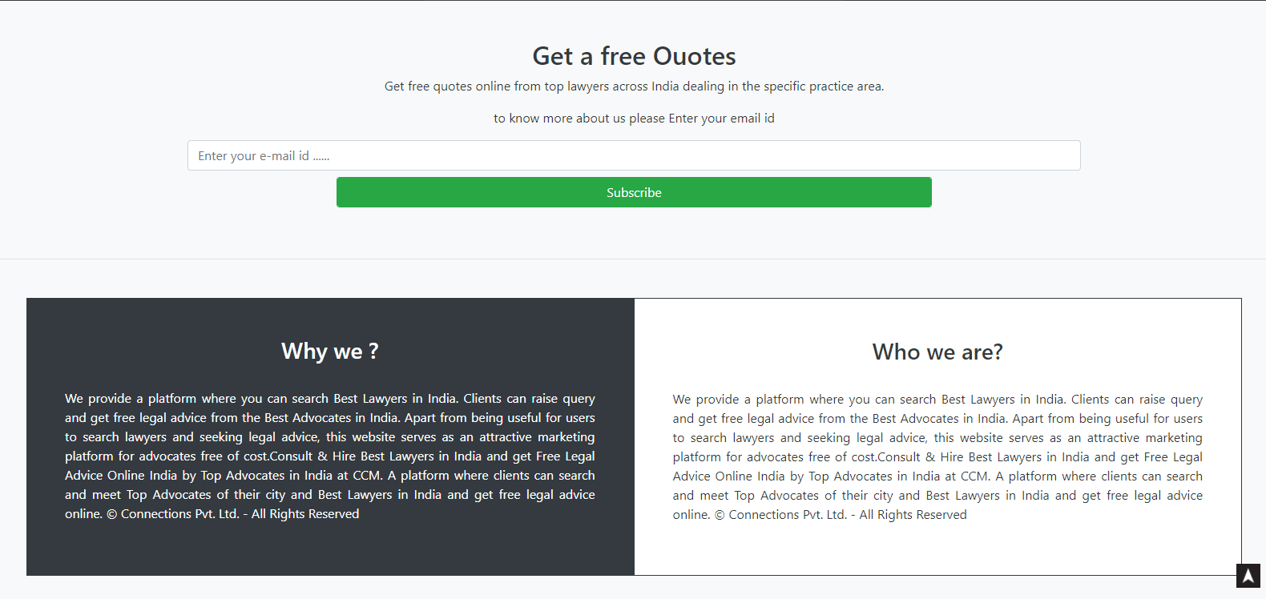

*Fig.A1.1 Home Page*

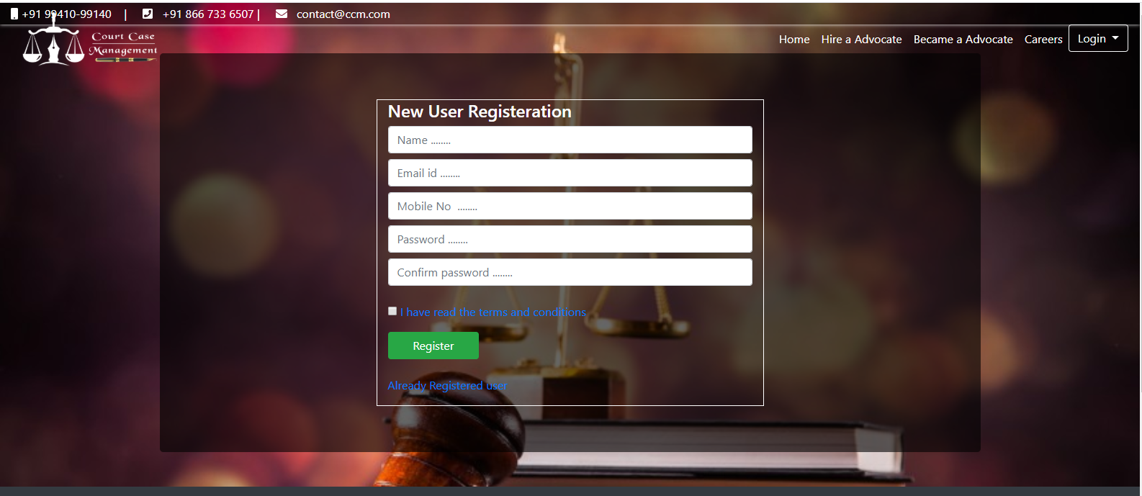

*Fig.A1.1 New Petitioner Registration*

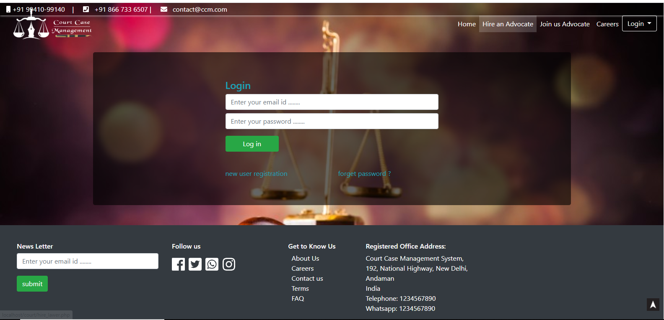

*Fig.A1.2 Petitioner Login*

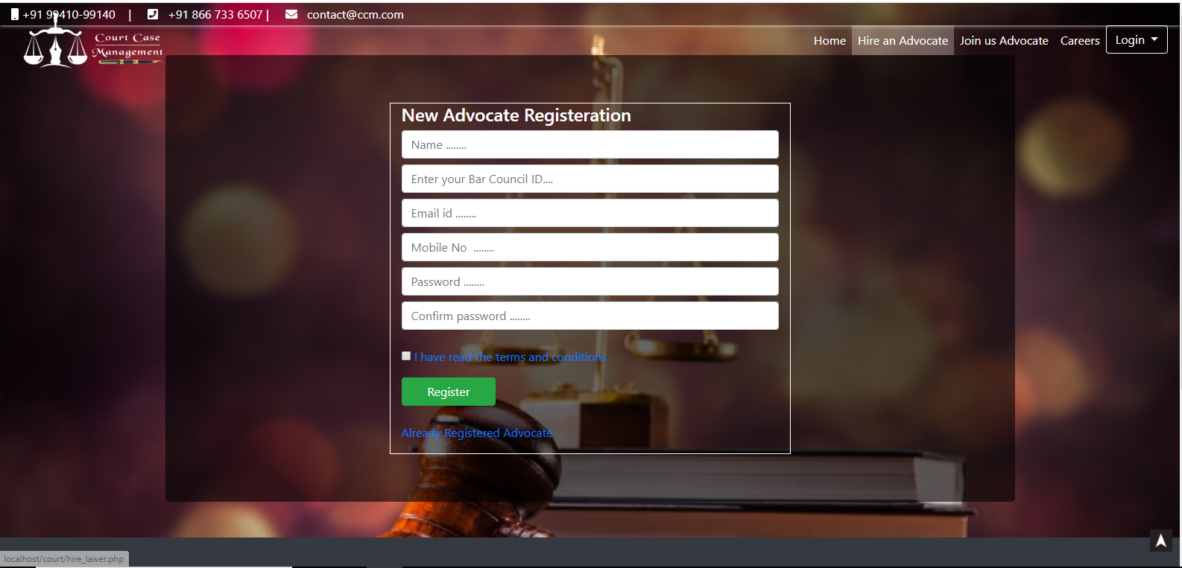

*Fig.A1.1 New Advocate Registration*

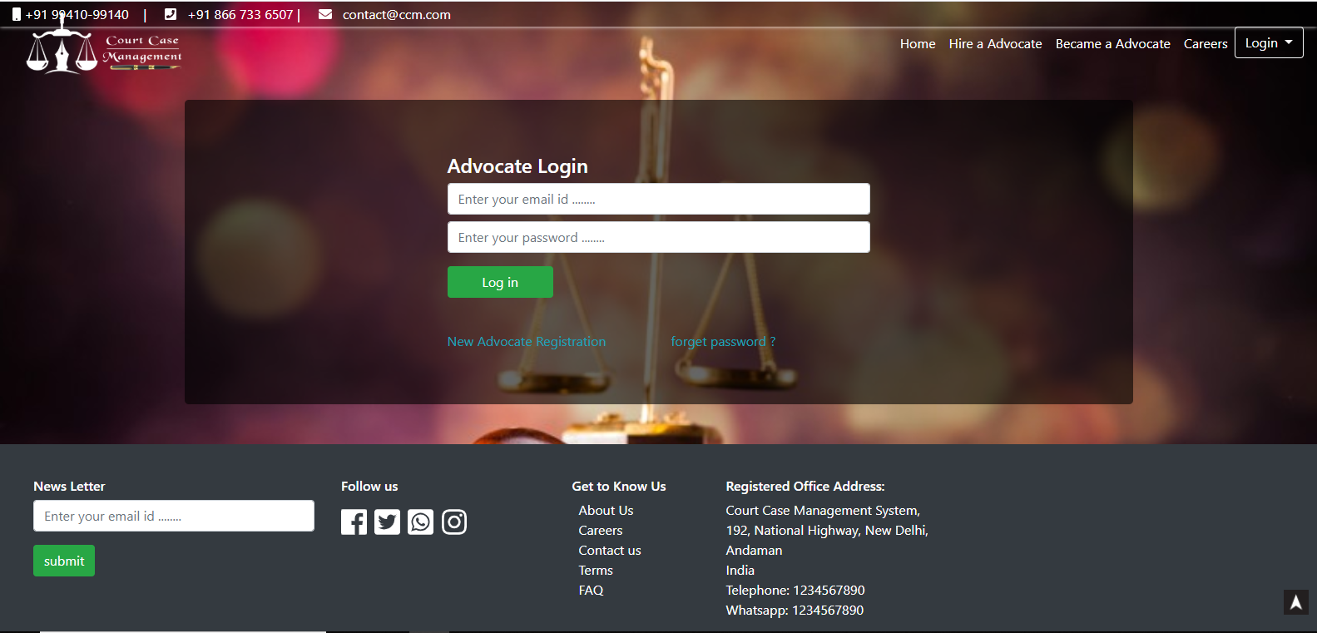

*Fig.A1.2 Advocate Login*

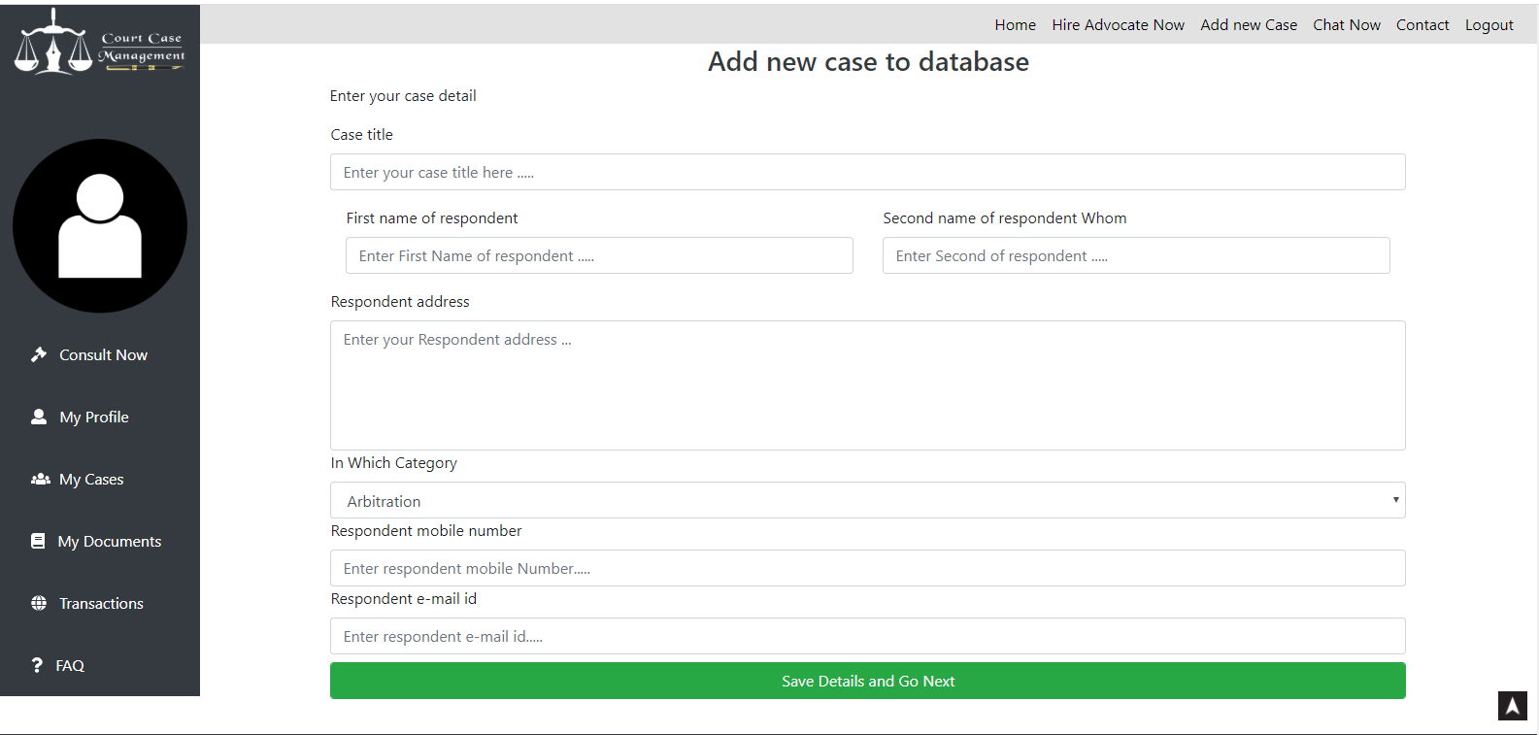

*Fig.A1.3 Add cate*

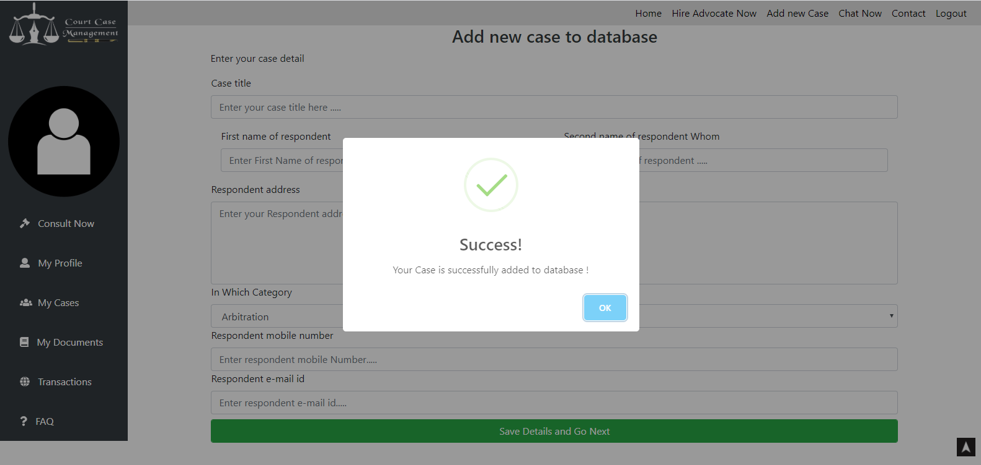

*Fig.A1.4 Case stored in database*

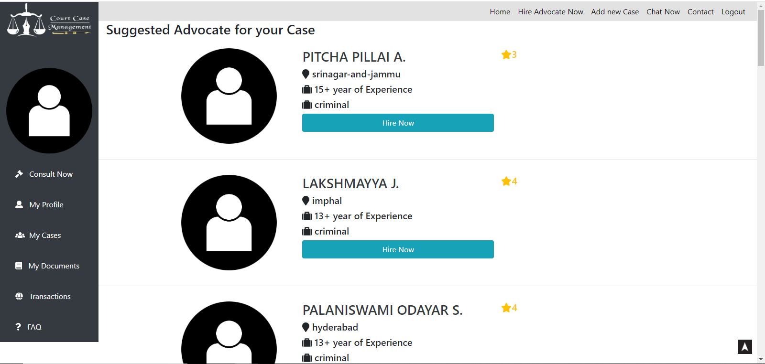

*Fig.A1.5 Advocate Recommendation based on case detail*

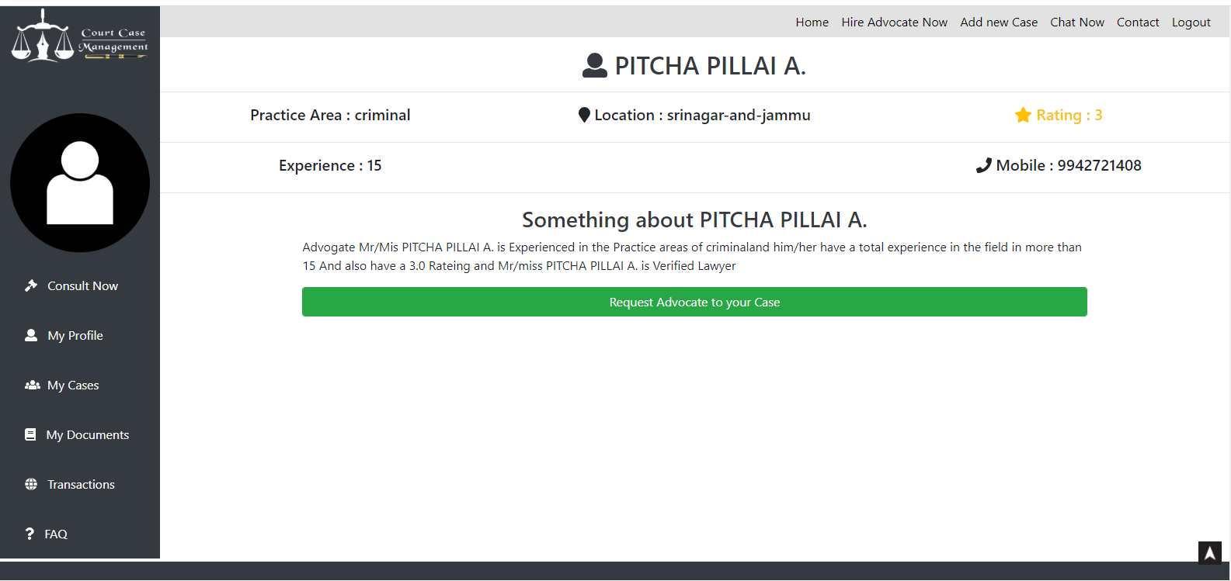

*Fig.A1.6 Advocate Full detail*

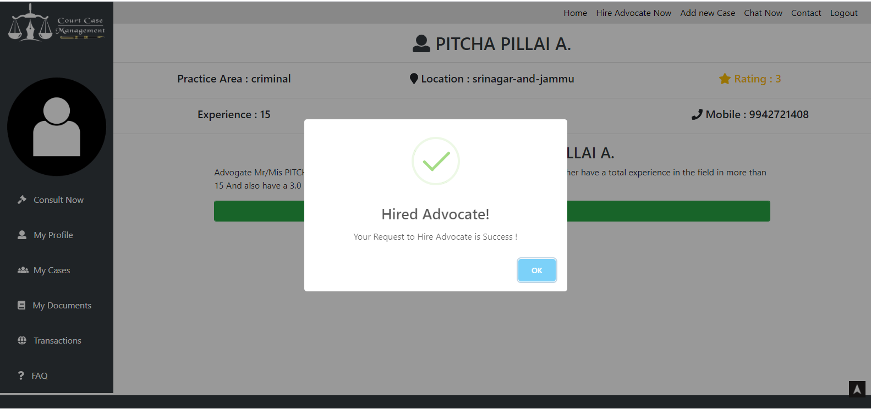

*Fig.A1.7 Request advocate to Handle case*

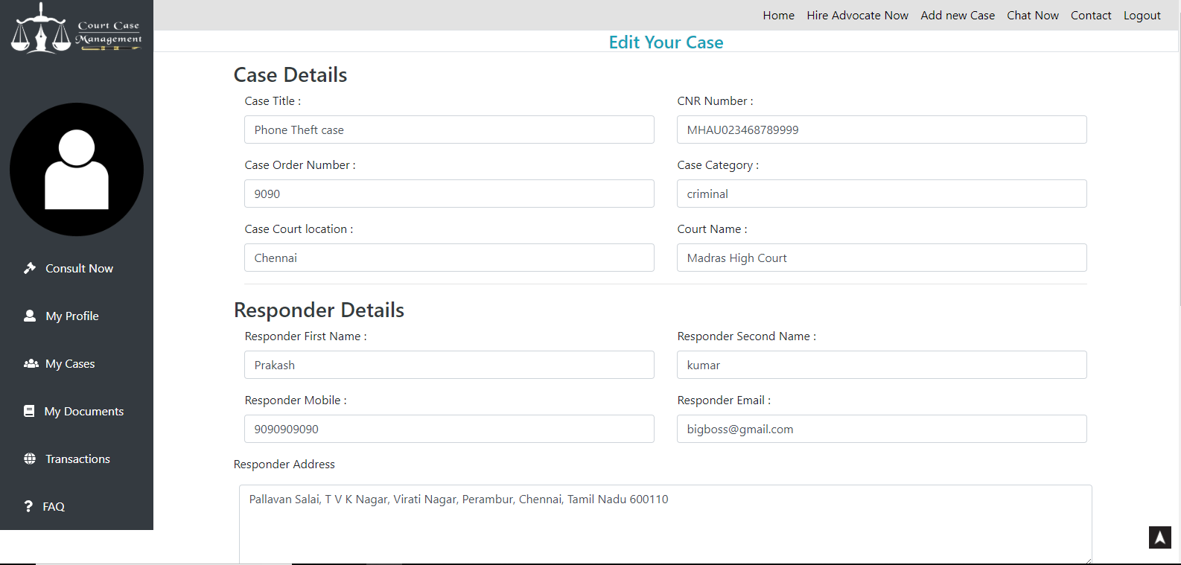

*Fig.A1.8 Case Details Update*

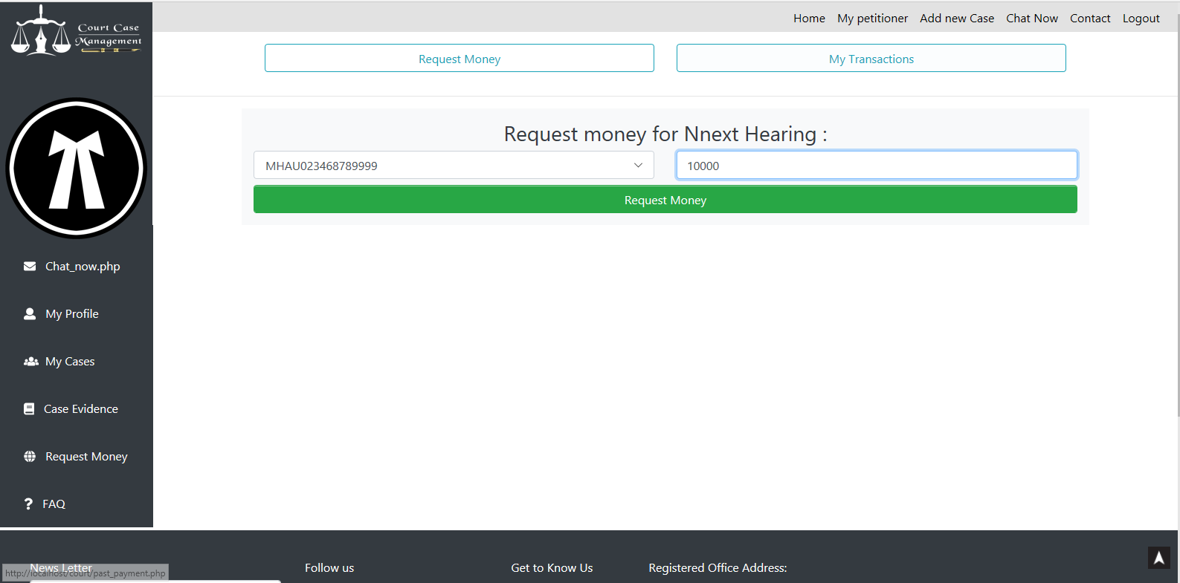

*Fig.A1.9 Request Money*

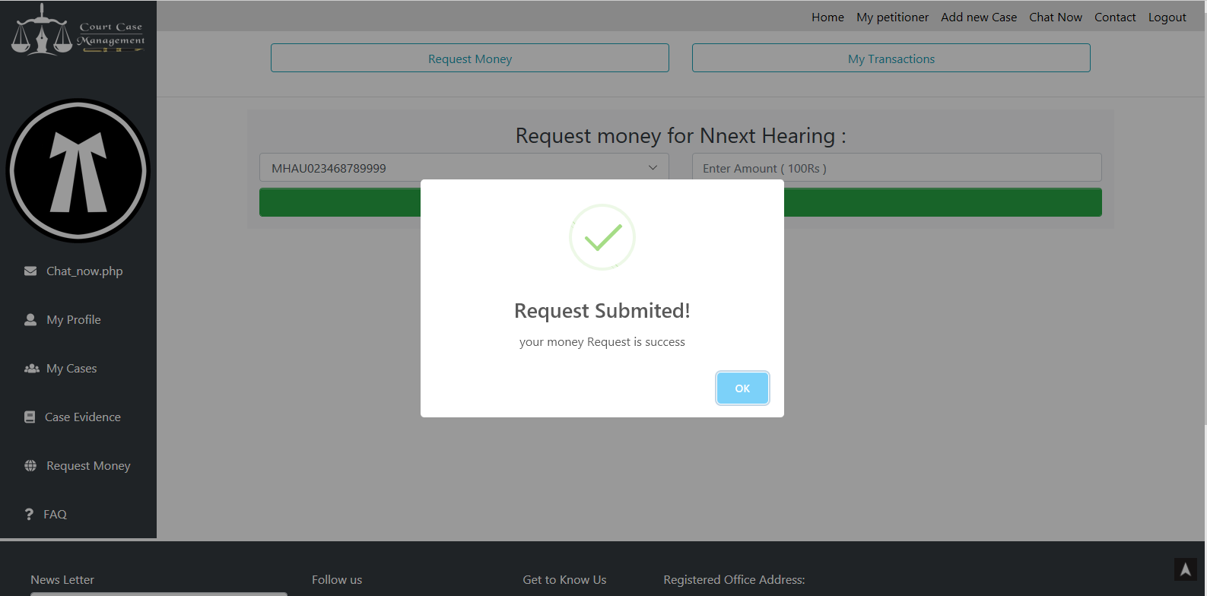

*Fig.A1.10 Request Success Alert*

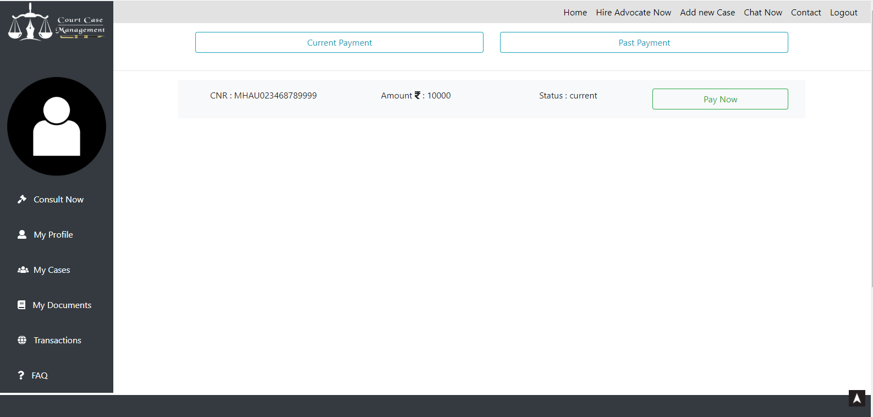

*Fig.A1.11 Money request in Petitioner dashboard*

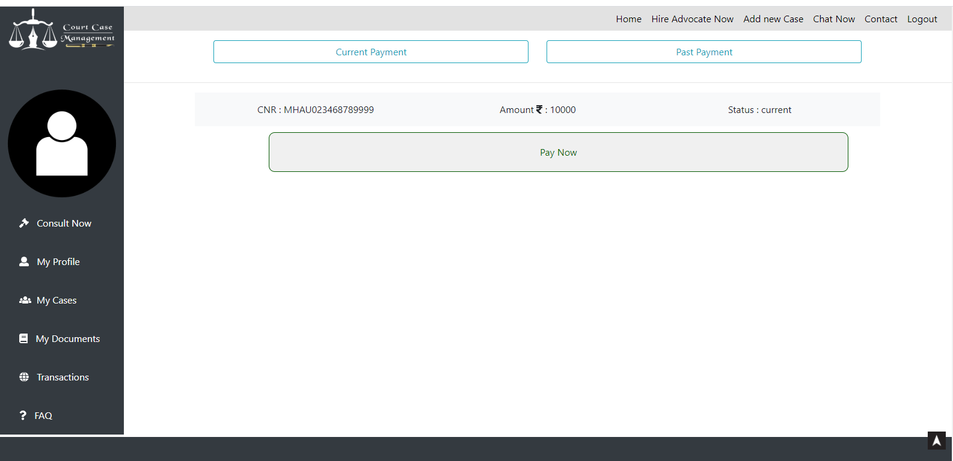

*Fig.A1.12 Money Pay Now button*

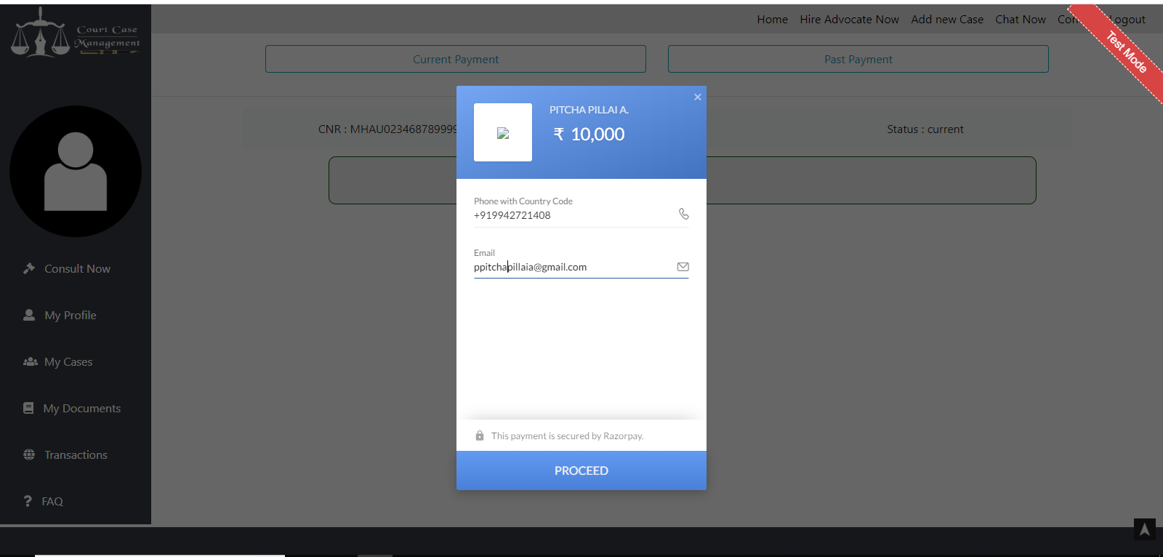

*Fig.A1.13 Razorpay Online Transaction*

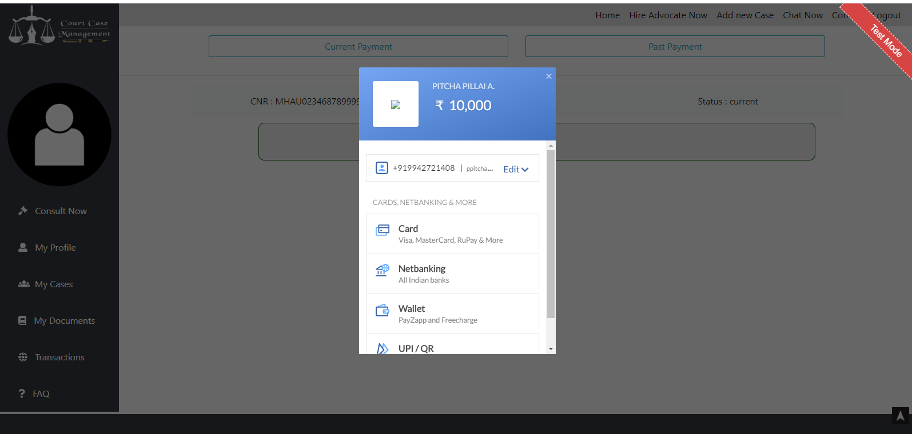

*Fig.A1.14 Selecting transaction type*

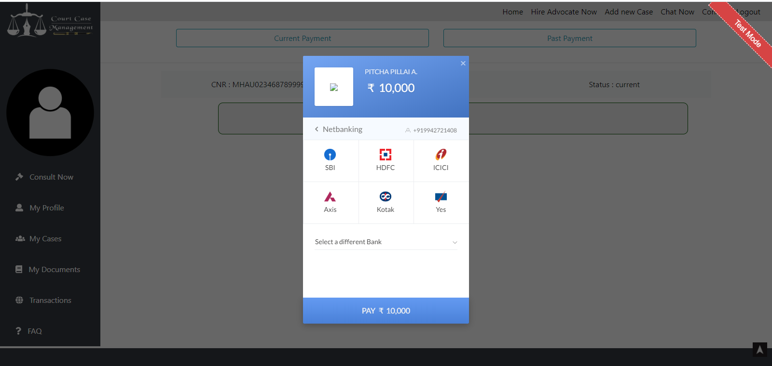

*Fig.A1.15 Net banking Chosen*

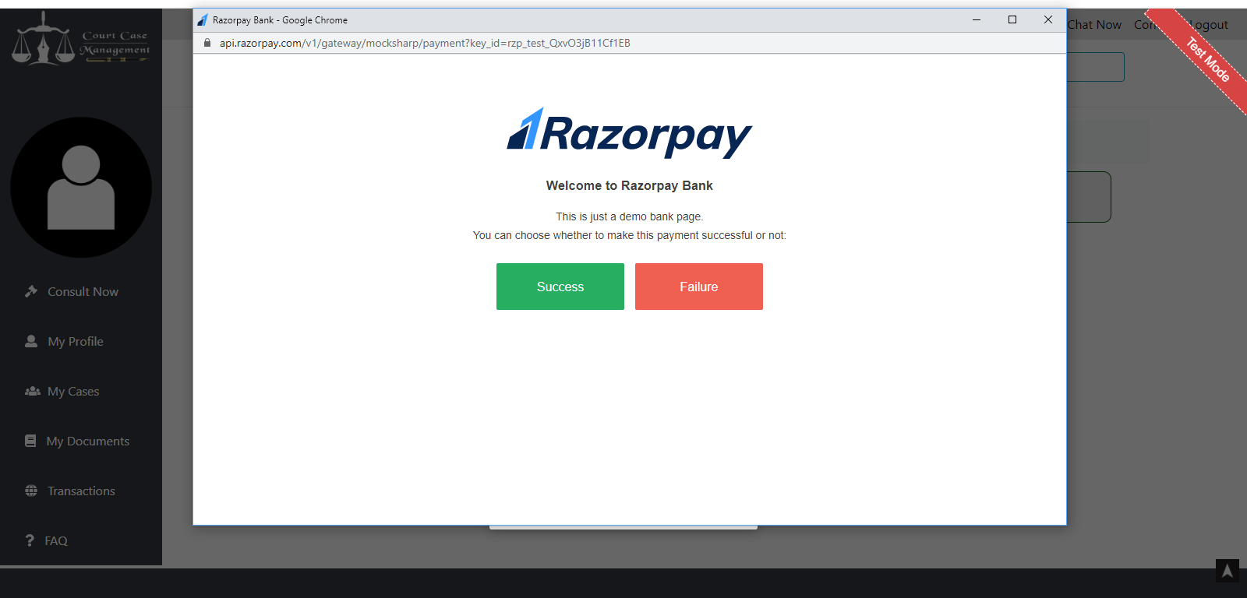

*Fig.A1.16 Transaction Page*

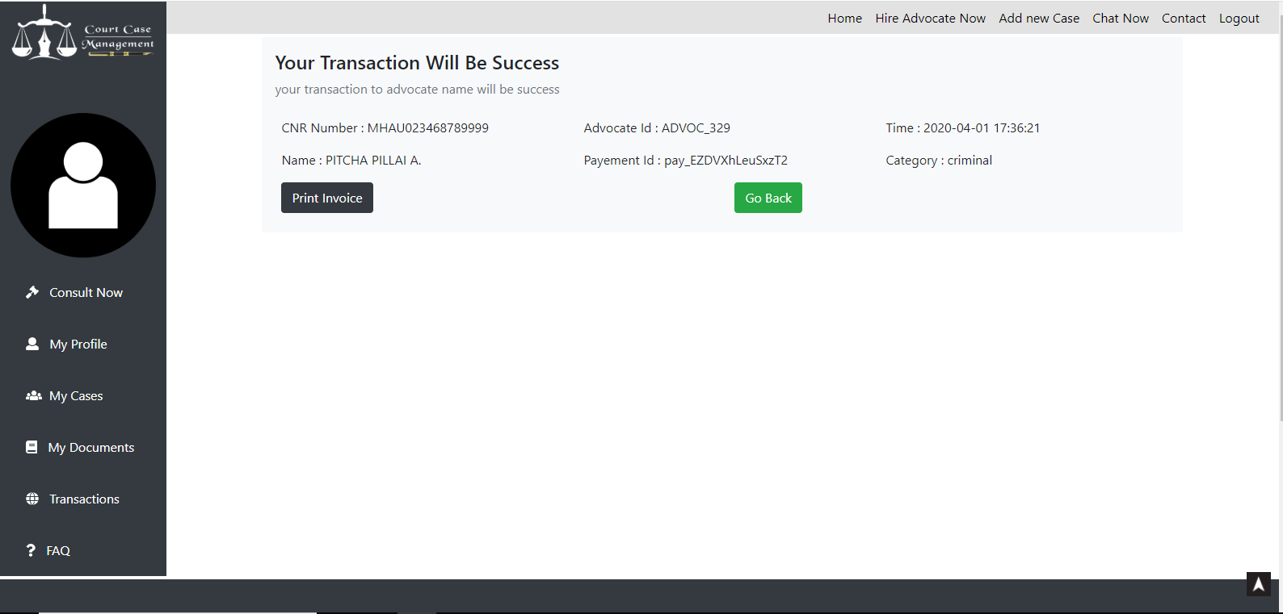

*Fig.A1.17 Transaction success alert*

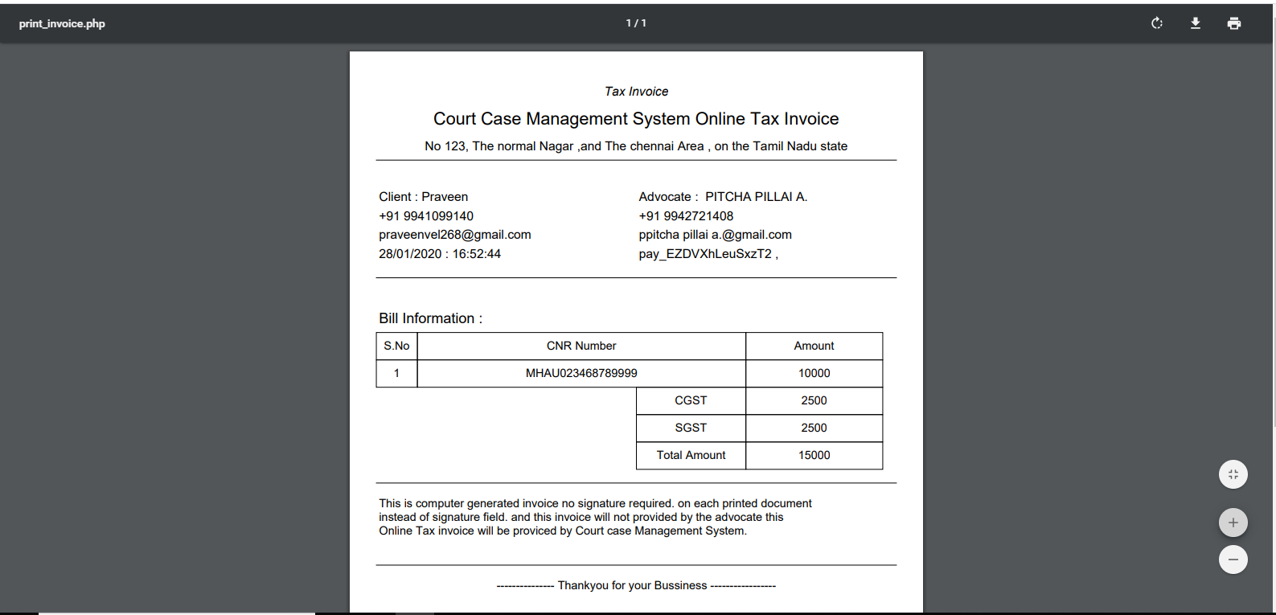

*Fig.A1.18 Invoice is printed*